# PL/SQL - Packages

## 1.1 Packages

Packages – hold it all together.

They have a package specification and a package body.

Type in this **package specification** code for this task is below, in SQL Commands, then view the code in Object Browser.

Discuss in pairs, what is this code doing?

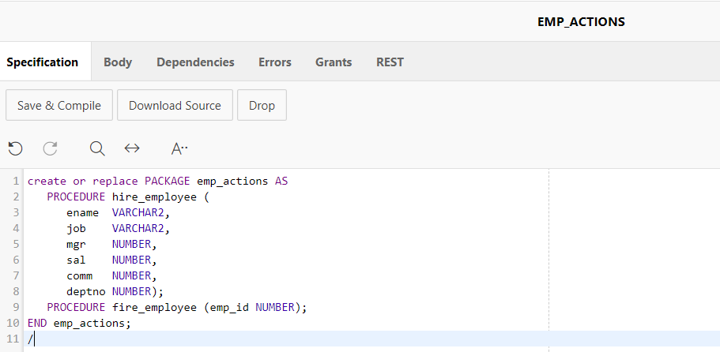

## 1.2 Package body for book

Type in this **package body** code in SQL Commands:

Have you got emp_seq and or the tables used in the code above? If not make sure you create these.

## 1.3 Test Package

The simplest way to test is to run from SQL commands:

BEGIN

emp_actions.hire_employee ('jj', 'boss', '7499','9999','', '30');

END;

/

What is missing here? Which fields are not specified, yet data is entered? Review the code and share with your peers.

Now try to run code to fire employee 1 (that was entered with the sequence). If you try to drop 7499, it is linked to another column, which would cause referential integrity issue.

## 1.3 Packages: Try it yourself

Create a function – get no of employees in a department

Create procedures: remove_emp, create_emp, update_emp (you may/should) have already done this. Test them in SQL commands.